Highlander Fight Song
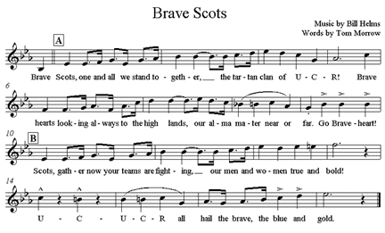

Brave Scots, one and all we stand to-geth-er,___ the tartan clan of U – C – R! Brave
Scots look-ing al-ways to the high lands, our al-ma ma-ter near or far. Go Brave-Scots!
Scots, gath-er now your teams are fight–ing,___ our men and wo-men true and bold!
U - C - U - C - R all hail the brave, the blue and gold.

Alma Mater


